Creating Sections and Articles in Zendesk

- Click the 4 squares in the top right and select “Knowledge”:
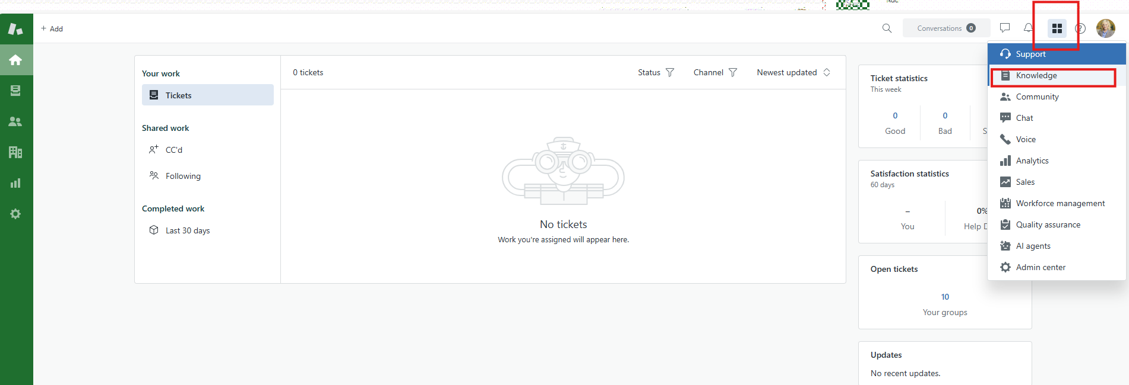

- Select “Add”, in the top right, then select Section:
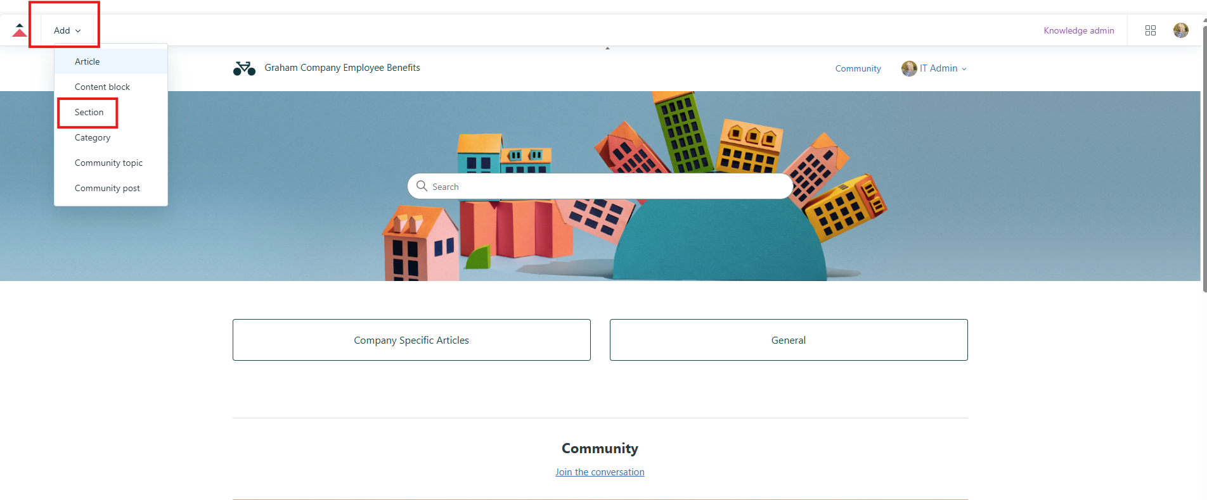

- Enter the Company Name to create a new section for that company’s articles in the “Name” box:
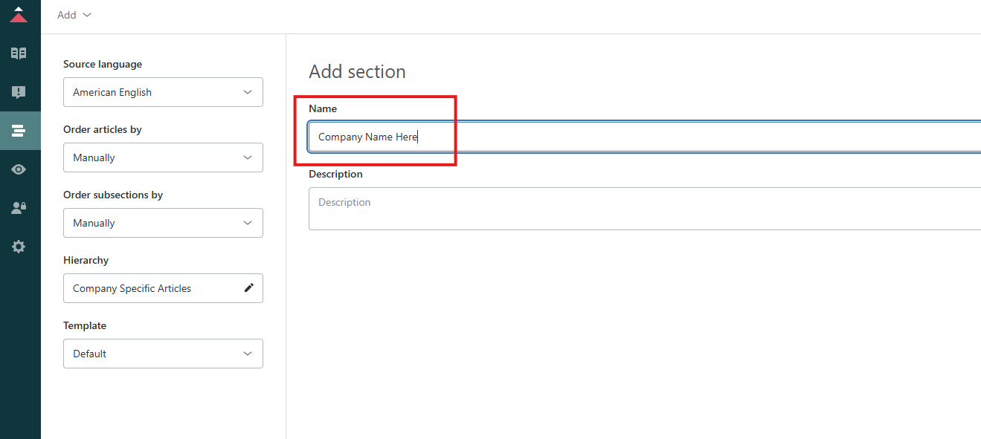

- On the left, select the pencil for Hierarchy
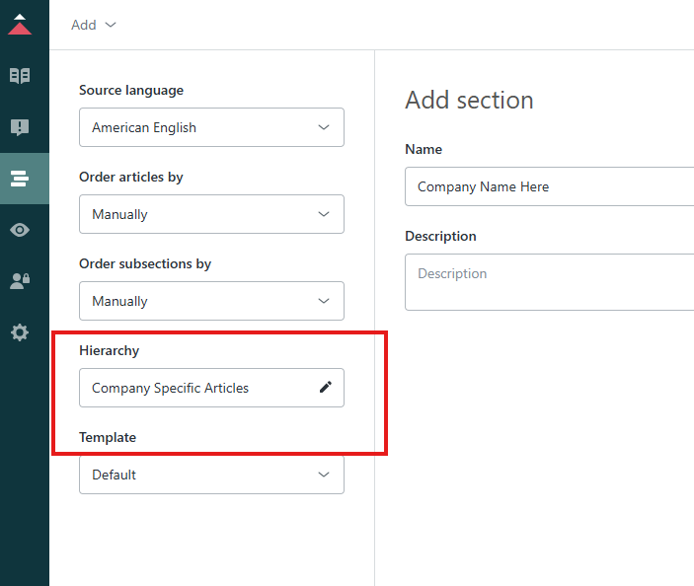

- Select Company Specific Articles:
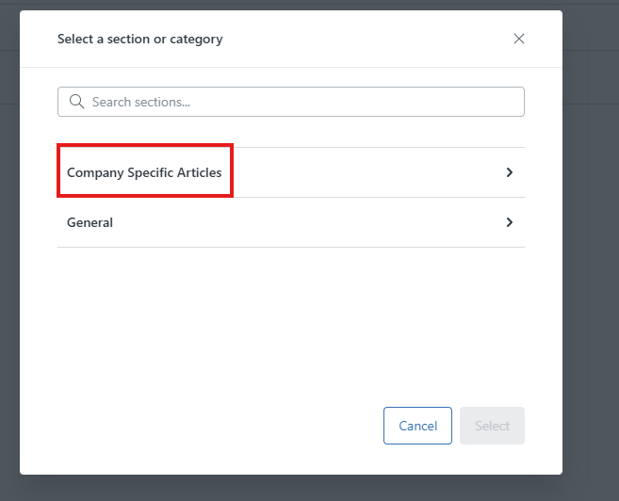

- Don’t select a company name here since you are adding one. Just hit the Select button:
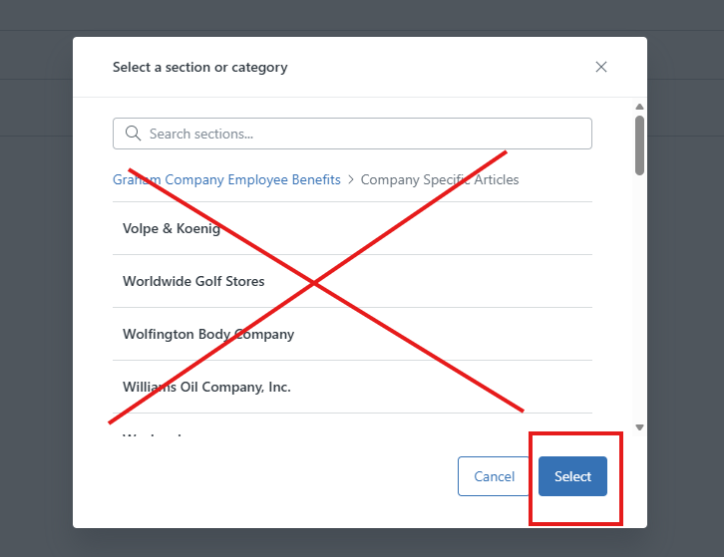

- Then in the top right, after hitting select, hit “Add”:
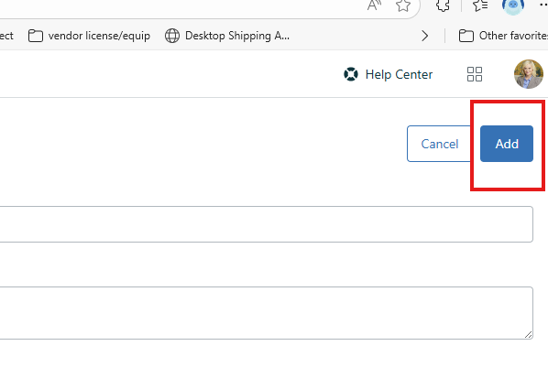

- Then to add an article, go back to the add option in the top left and select article:
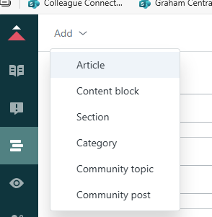

- Then, give your article a descriptive name. add the link or copy paste info into the body section, (or attach file shown later). Then on the right, select Manage Sections:
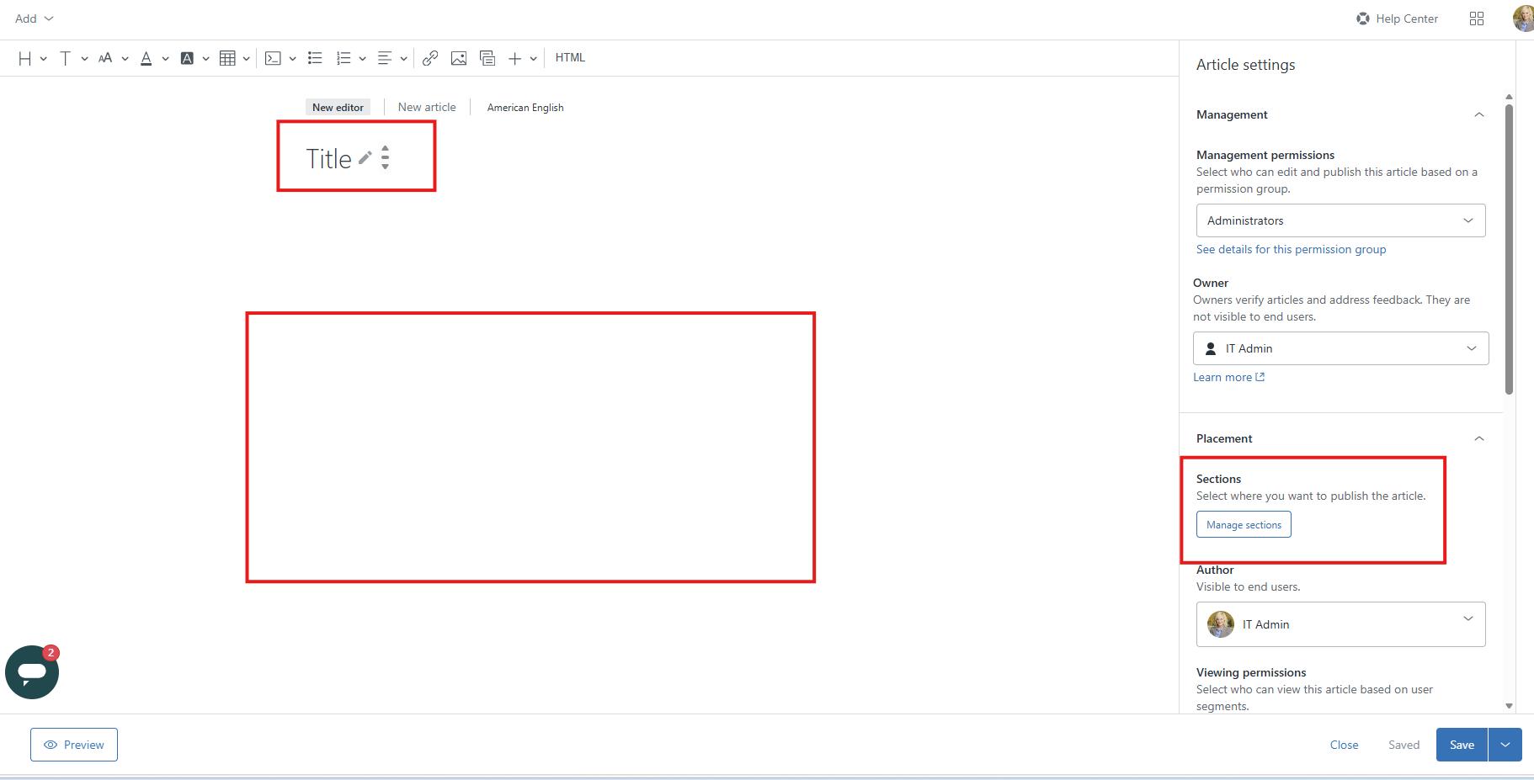

- Then, search for the org section you are linking to in the search box, select the box to check it next to the org you want, then select done.
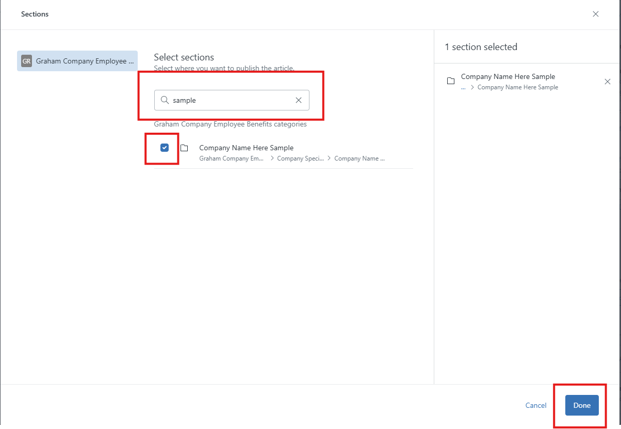
- Then select visible to everyone, add the tag associated with the org you are linking to (this can be found by going to the org selection on the main page, then finding the desired org and applying/copying a tag or if it’s completely new, type in the desired tag and select add as new: 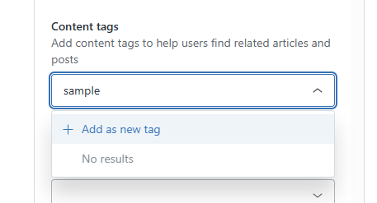)
Then select manage attached media:
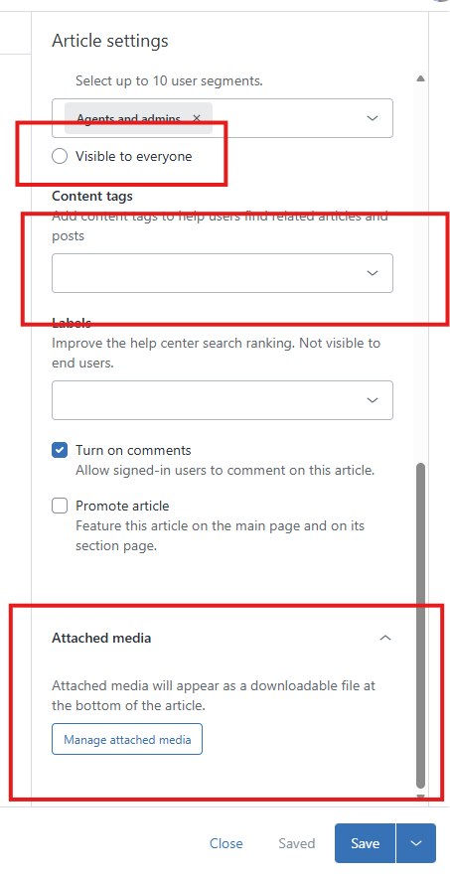

- Then select upload media, navigate to the media, select open, then attach media:
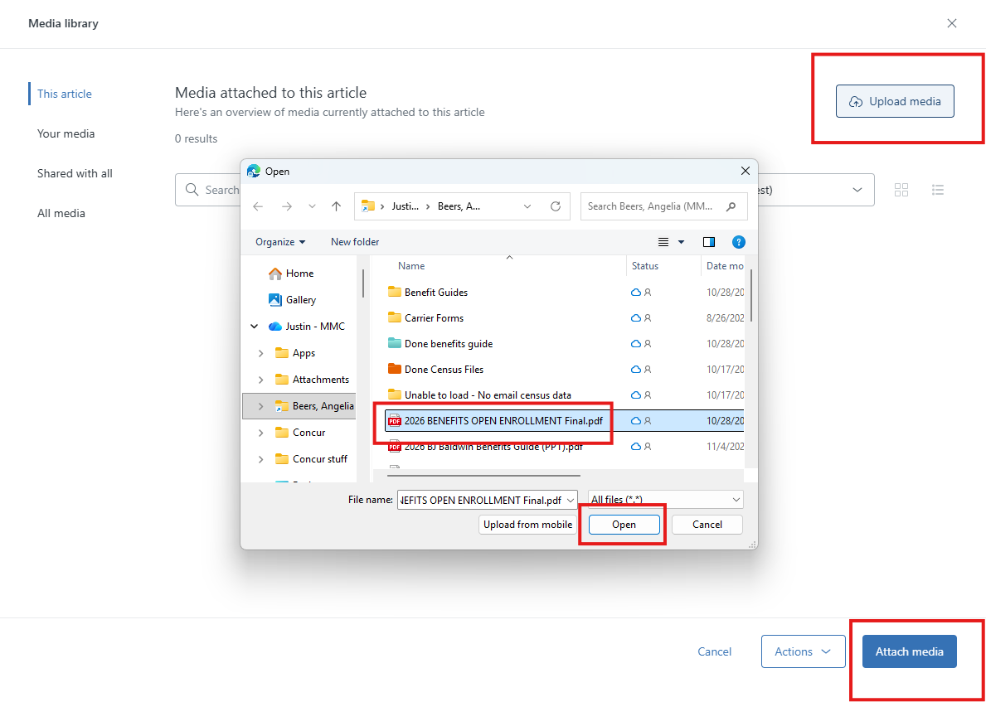

- Then select Save
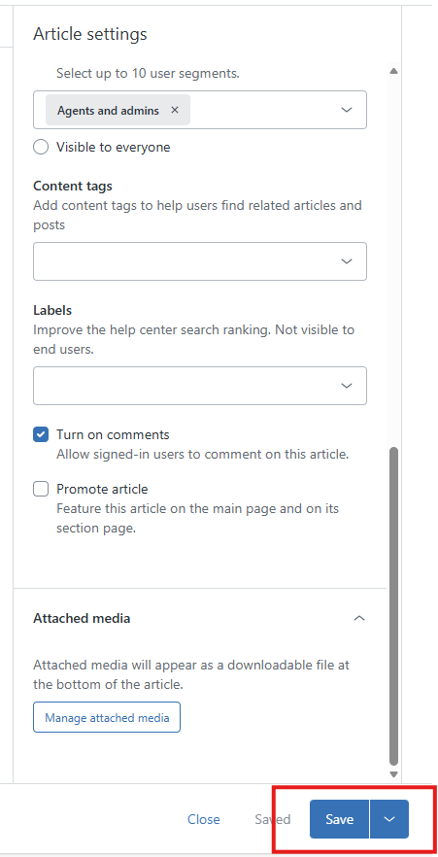

- Then hit the drop down on the right of Save and select Publish:
